 Create a S3 bucket, with no public access and upload files to the bucket & view the logs using CloudWatch for the uploaded files

Creating the bucket with public access

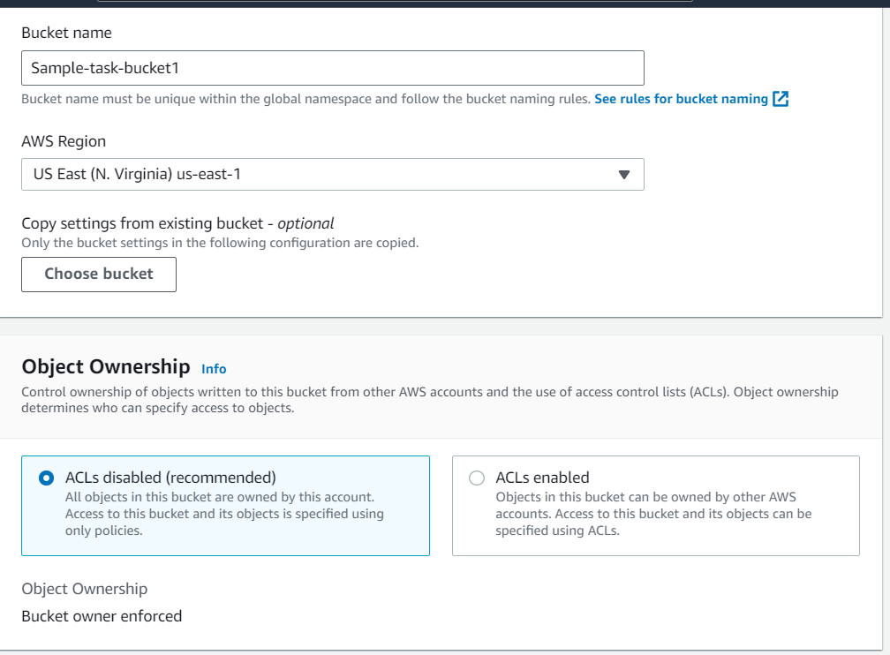

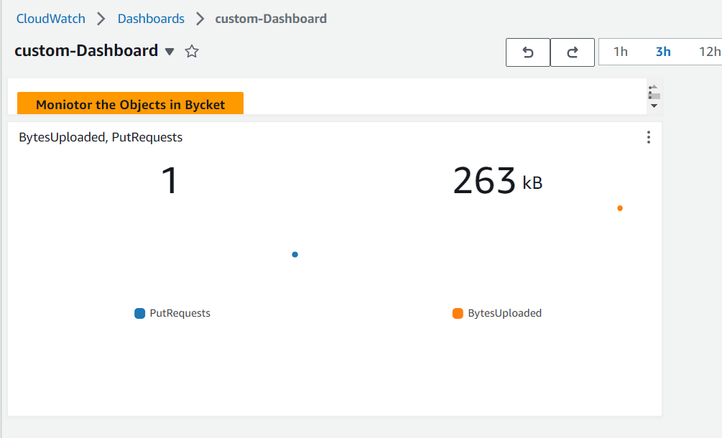

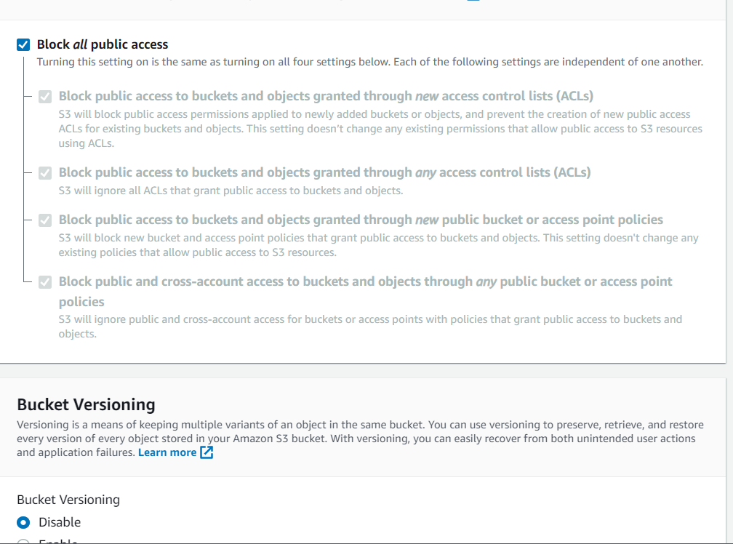

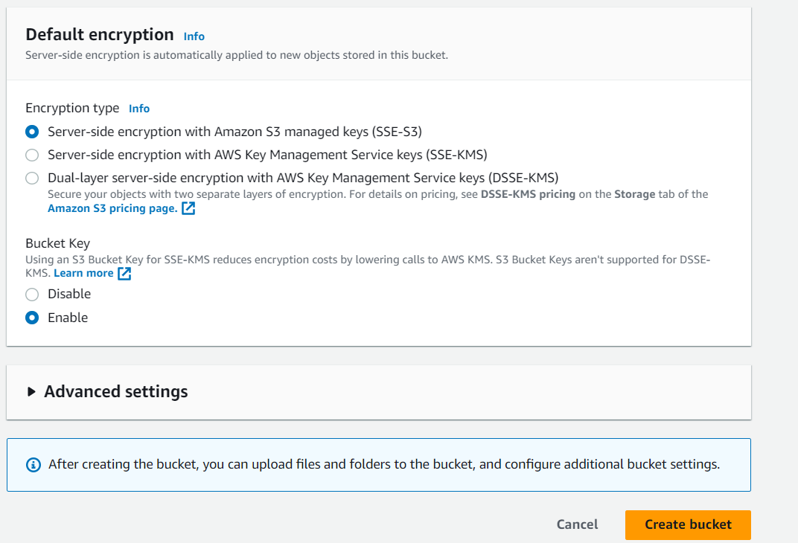

Upload the files to the buckets

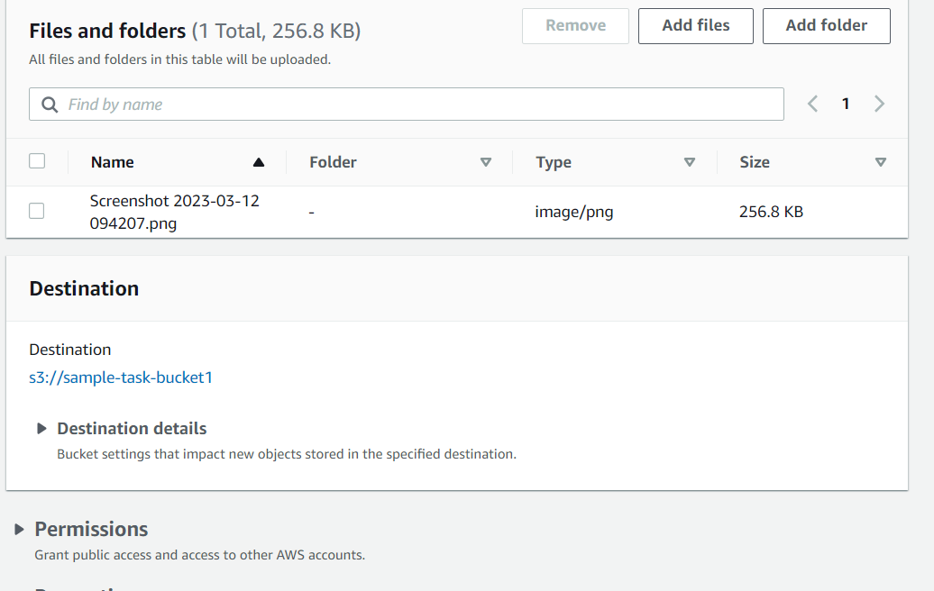

Launch two ec2-instances and connect it to a application load balancer, where the output traffic from the server must be an load balancer IP address

1. Creating the 2 instances in the ubuntu environment



1. Installing the Nignix server and create the website on both the servers

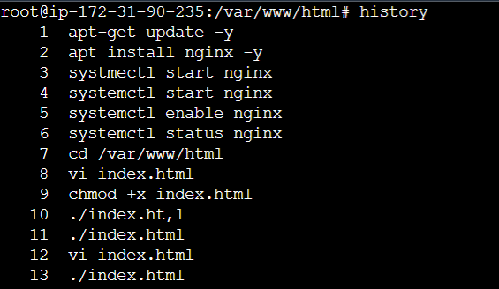

Creating the Load balancer -Application Load balancer

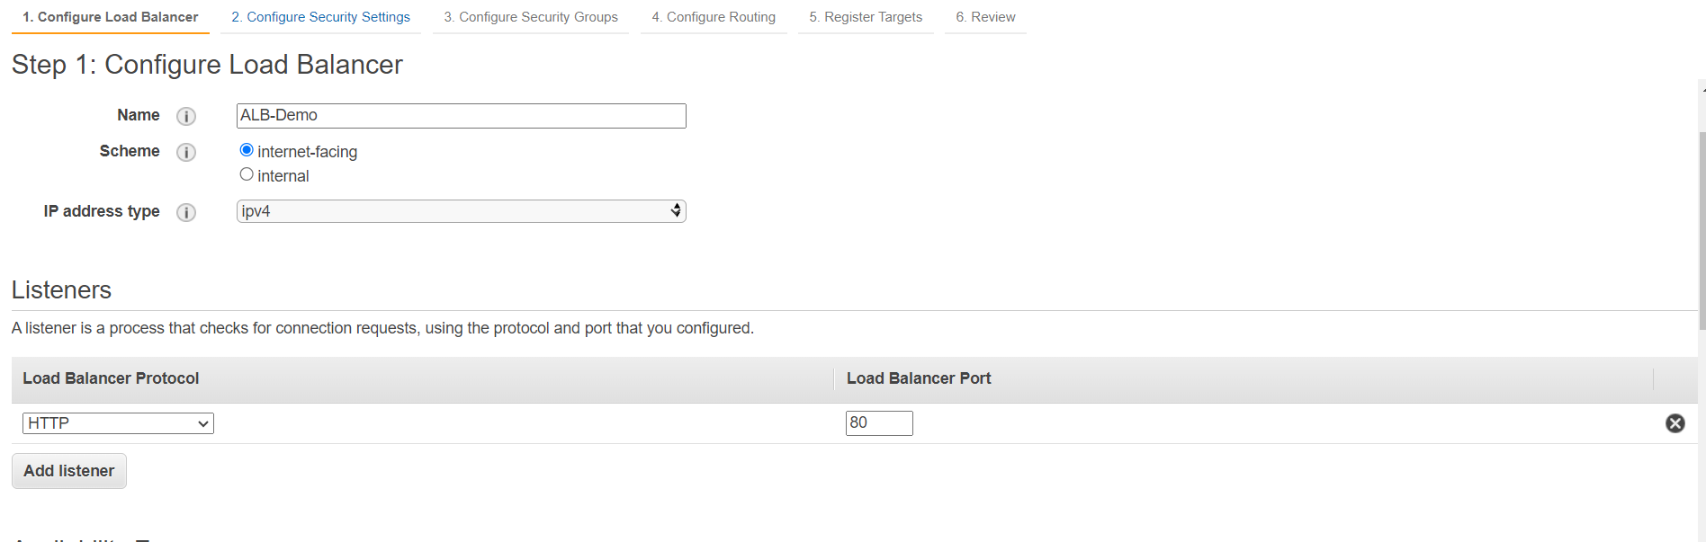

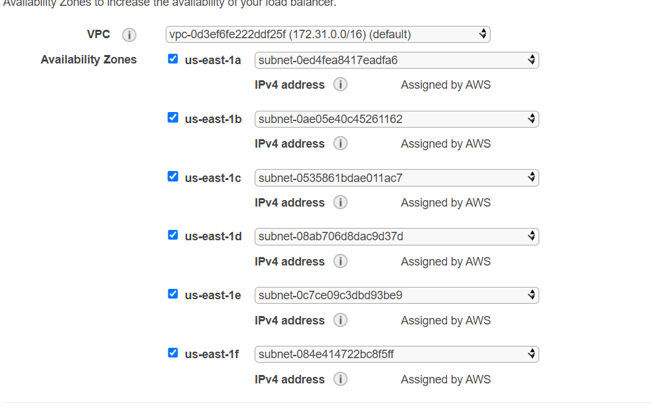

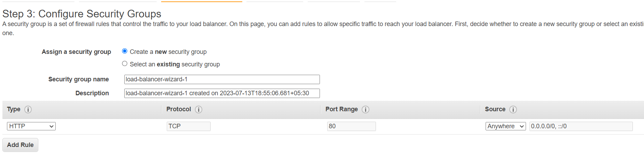

Creating & Register the Target group

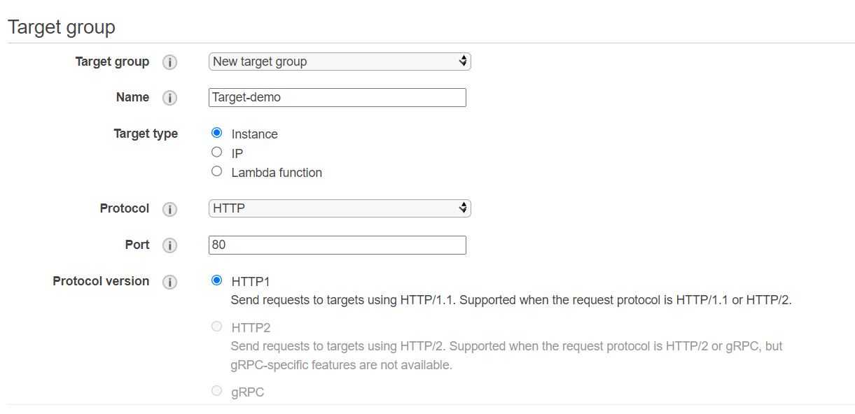

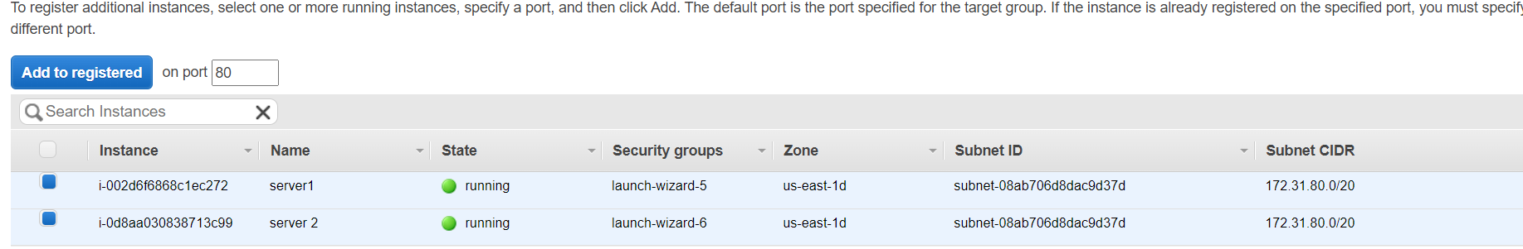

Access the server from the Load balancer DNS Name

